**TENDERHUB**

A report submitted for the course

**Application Development_ Cloud Explore**

**III B.Tech. I Semester**

**by**

**M. Nandini - 2211CS030102**

**M .Srinija - 2211CS030103**

**Srinethri Shinde - 2211CS030153**

**V. Mamatha - 2211CS030150**

Under the esteemed guidance of

**Mrs. Krushima Soma**

**(Asst.Professor)**



**Department of Data Science**

**Malla Reddy Univeristy**

Maisammaguda, Dulapally,

Hyderabad, Telangana 500100  
[www.mallareddyuniversity.ac.in](http://www.mallareddyuniversity.ac.in/)  
**2024-25**

***CERTIFICATE***

This is to certify that this bonafide record of the Application Development entitled **TenderHub** submitted by **Ms. M. Nandini (2211CS030102), Ms. M. Srinija (2211CS030103), Ms. Srinethri Shinde (2211CS030153), Ms. V. Mamatha (2211CS030168)** of  **III** year **I** semester to the Malla Reddy University, Hyderabad. Thisbonafide record of work carried out by us under the guidance of our supervision. The contents of this report, in full or in parts, have not been submitted to any other Organization for the award of any Degree.

|  |  |  |
| --- | --- | --- |
| **Internal Guide:**  **Ms.Krushima Soma**  **Assistant Professor** |  | **Dean, Data Science**  **Dr.GS Naveen Kumar** |
|  | **External Examiner** |  |

**Date:**

**ABSTRACT**

TenderHub is a comprehensive tender management system designed to address the growing need for streamlined and transparent tendering processes. In an era where organizations manage multiple tenders and bids simultaneously, traditional methods often lead to inefficiencies, lack of accountability, and delays. TenderHub provides a centralized platform for administrators and bidders, ensuring clear communication and effective management of tender-related activities. By digitalizing the process, the application reduces paperwork, minimizes errors, and enhances operational efficiency. For administrators, it simplifies vendor management and bid evaluation, fostering better decision-making. Bidders benefit from an organized view of tender opportunities, seamless bid submission, and tracking capabilities, making it easier to engage with tenders competitively. Deployed on AWS Elastic Beanstalk and powered by a scalable database, TenderHub is built to handle varying workloads, ensuring reliability for businesses of all sizes. By fostering transparency, reducing administrative overhead, and promoting fair competition, TenderHub positions itself as a vital tool for modern organizations to enhance their tendering workflows and achieve greater operational efficiency.

**CONTENTS**

|  |  |  |
| --- | --- | --- |
|  |  |  |

|  |  |  |
| --- | --- | --- |
| Certificate | | i |
| Abstract | | ii |
| Contents |  | iii |
| List of Figures | | iv |
| List of Abbreviations | | v |
| Chapter1 | Introduction | 1 |
|  | 1.1 Introduction to TenderHub | 1 |
|  | 1.2 Crafting The Solutions | 1 |
|  | 1.3 Benefits of TenderHub | 2 |
| Chapter2 | Review of Relevant Literature | 3 |
| Chapter3 | Methodology | 4 |
| Chapter4 | Results and Discussions | 6 |
| Chapter5 | Conclusion and Future Scope of Study | 13 |
| References |  | 15 |

**LIST OF FIGURES**

|  |  |  |
| --- | --- | --- |
| **Figure** | **Title** | **Page** |
| 3.1 | Methodology | 5 |
| 4.1 | Register Page | 6 |
| 4.2 | Login for Admin | 6 |
| 4.3 | Home Page for Admin | 7 |
| 4.4 | Vendor Page for Admin | 7 |
| 4.5 | Create Vendor Page for Admin | 8 |
| 4.6 | Vendor Detail Page for Admin | 8 |
| 4.7 | Tender Page for Admin | 9 |
| 4.8 | Create Tender Page for Admin | 9 |
| 4.9 | Tender Details Page for Admin | 10 |
| 4.10 | User login | 10 |
| 4.11 | Home Page for User | 11 |
| 4.12 | Tender Page for User | 11 |
| 4.13 | Place Bid Page for User | 12 |
| 4.14 | Bid Page for User | 12 |

**LIST OF ABBREVIATIONS**

HTML - Hyper Text Markup Language

CSS - Cascading Style Sheets

RDS - Relational Database Service

**Chapter 1: Introduction**

**1.1 Introduction to TenderHub**

Tender management is a crucial process for organizations, involving the procurement of services, goods, or contractors. However, traditional approaches often lack efficiency, leading to delays, miscommunication, and errors. Administrators frequently struggle with tracking multiple vendors and tenders, ensuring compliance, and managing large amounts of data without a centralized system. This results in tedious workflows, missed deadlines, and difficulty maintaining transparency in bid evaluations.

For bidders, the challenges are equally significant. Accessing relevant tenders, understanding requirements, and staying updated on bid statuses becomes a frustrating ordeal without a streamlined platform. These pain points not only hinder operational efficiency but also erode trust among stakeholders. The absence of a digital solution exacerbates these issues, creating a pressing need for a system that can automate processes, enhance transparency, and improve communication between administrators and bidders. Recognizing these challenges laid the foundation for the creation of TenderHub.

**1.2 Crafting the Solutions**

1. **Centralized Platform for Transparency**

TenderHub was designed to centralize all tender-related activities, providing a unified system where administrators and bidders can collaborate effectively. By consolidating vendor details, tender statuses, and bid information, it ensures all stakeholders have access to accurate and up-to-date data.

1. **User-Friendly Interface**

Built using Flask, HTML, and CSS, the application prioritizes simplicity and usability. Features such as interactive dashboards and card-based layouts make navigation intuitive for both administrators and bidders, reducing the learning curve and improving user experience.

1. **Streamlined Administrative Tasks**

For administrators, TenderHub offers tools to create and manage vendors, tenders, and bids with ease. Automated workflows eliminate redundancies, allowing them to focus on strategic decision-making rather than manual processes.

1. **Empowered Bidders**

TenderHub simplifies the bidding process, enabling bidders to access relevant tenders, submit detailed bids, and track their statuses in real time. This creates a transparent and organized system for all participants.

1. **Scalability and Reliability**

Hosted on AWS Elastic Beanstalk with RDS, TenderHub is built to handle the demands of growing organizations. Its cloud-based infrastructure ensures reliability, security, and the ability to scale as needed.

**1.3 Benefits of TenderHub**

TenderHub delivers transformative benefits to organizations by addressing the core challenges of tender management. By automating and centralizing tender-related activities, it empowers administrators to focus on strategic decision-making rather than manual processes. The platform enhances operational efficiency by streamlining vendor management, tender creation, and bid evaluation. For bidders, TenderHub creates a seamless experience, allowing them to explore relevant tenders, submit bids with precision, and track their progress in real time. The system's scalable architecture, powered by AWS Elastic Beanstalk, ensures reliability even under heavy usage. Additionally, the transparency and accountability fostered by TenderHub build trust between stakeholders, improving relationships and promoting fair competition. This combination of technological innovation and user-centric design makes TenderHub a vital tool for modern organizations, helping them save time, reduce costs, and achieve their procurement goals with confidence and ease.

**Chapter 2: Review of Relevant Literature**

1. **"E-Procurement Systems and the Tendering Process"** by *L. L. Tsering (2019)*

This study highlights the benefits of e-procurement systems, such as enhanced transparency, reduced administrative overhead, and streamlined bid tracking. It underscores the role of digital platforms in creating a more competitive and efficient tendering environment, aligning with TenderHub's objectives of improving efficiency and transparency in tender management.

2. **"A Comprehensive Study on Tender Management Systems"** by *S. Sharma and R. Singh (2020)*

This research discusses the transition to digital tender management systems that integrate cloud computing and AI for better scalability and automation. It highlights how cloud-based systems like TenderHub, utilizing AWS and AI, can efficiently manage tenders, bids, and vendor evaluations in real time, enhancing system performance.

3. **"The Role of Automation in Enhancing Tendering Efficiency"** by *M. Wang (2021)*

Wang’s research emphasizes how automation in tendering processes improves efficiency by reducing errors and speeding up workflows. It advocates for the use of AI to analyze bids and vendor profiles, suggesting that such features could optimize tender selection—key features that TenderHub aims to incorporate for better decision-making.

**Chapter 3: Methodology**

1. **Requirement Analysis and Planning**

The first step involved gathering requirements from potential users to understand the pain points of the existing tender management process. Detailed discussions with stakeholders helped identify the core functionalities needed, such as vendor management, tender creation, bid submission, and tracking. This phase also focused on outlining the user roles and permissions for administrators and bidders to ensure clear access control within the application.

1. **System Design**

During the design phase, a comprehensive architecture was developed to ensure scalability, reliability, and a responsive user interface. The application was built using Flask, a lightweight Python web framework, for its simplicity and flexibility in building web applications. HTML and CSS were used for the frontend design to ensure a clean, responsive layout. AWS Elastic Beanstalk was chosen for deployment due to its managed environment, and RDS was used for secure, scalable database management.

1. **Development and Implementation**

The development process followed an iterative approach, beginning with core features such as vendor and tender creation, followed by the addition of bid management and user interaction elements. The application was built incrementally, ensuring that each new feature integrated smoothly with the existing functionalities. Bootstrap was used to design the frontend to ensure a modern, mobile-responsive layout. JavaScript and jQuery were implemented for interactive features like expanding cards and real-time bid tracking.

1. **Testing and Quality Assurance**

Once the application reached a functional state, rigorous testing was conducted. This included unit testing, integration testing, and user acceptance testing (UAT). The focus was on ensuring that the platform was bug-free, easy to use, and capable of handling real-world scenarios. Special attention was paid to ensuring that both administrators and bidders could use the application seamlessly.

1. **Deployment and Monitoring**

After testing, TenderHub was deployed on AWS Elastic Beanstalk. The platform was monitored for performance, security, and scalability. Continuous integration (CI) and continuous deployment (CD) pipelines were set up to ensure smooth updates and improvements in the future. Analytics and logs were used to monitor the system’s performance, user engagement, and identify areas for further optimization.

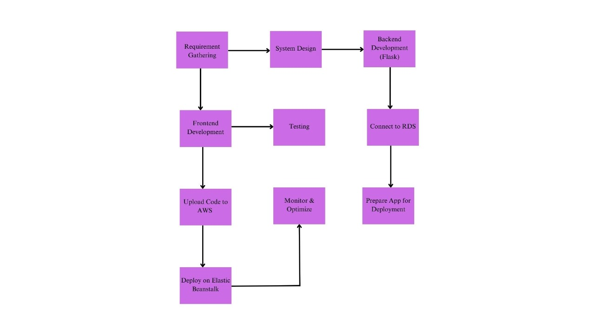

**Fig: 3.1-Methodology**

**Chapter 4: Results and Discussions**

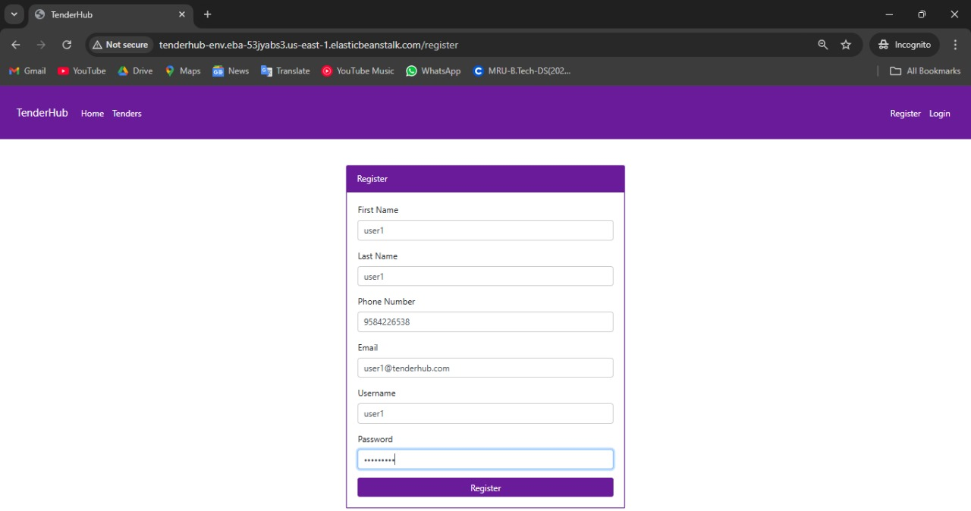

**Fig: 4.1 Register Page**

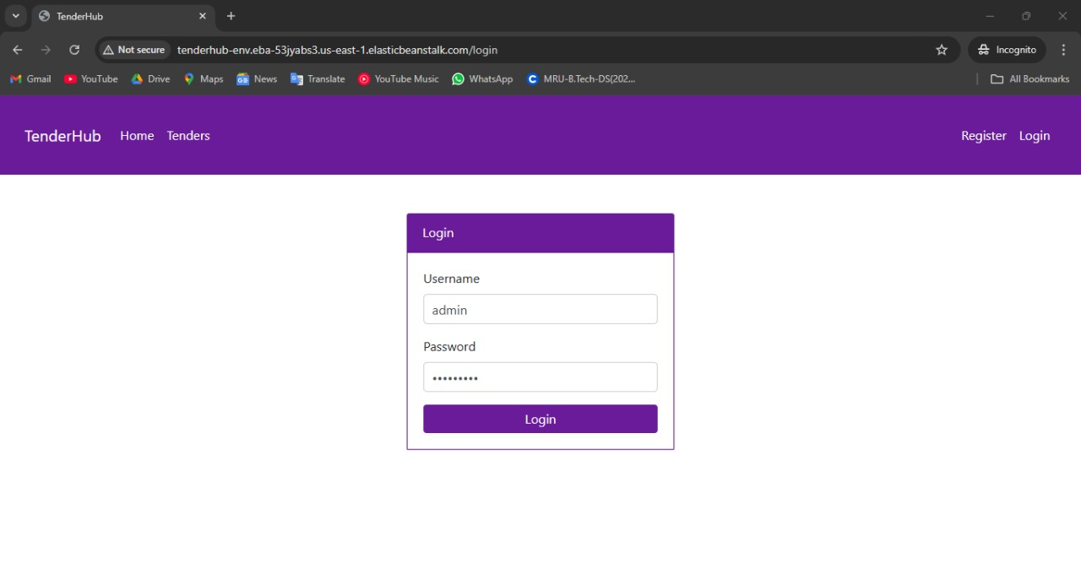

**Fig: 4.2 Login for admin**

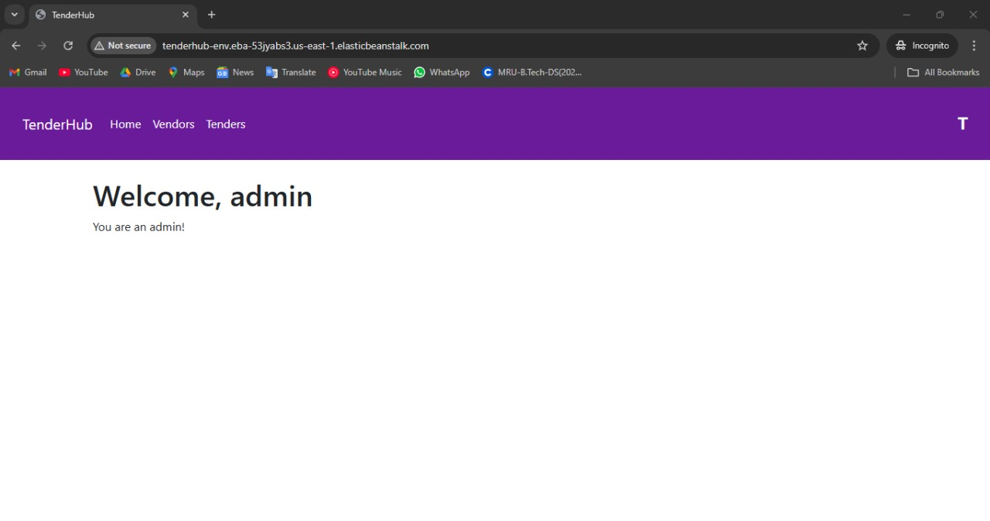

**Fig: 4.3 Home Page for Admin**

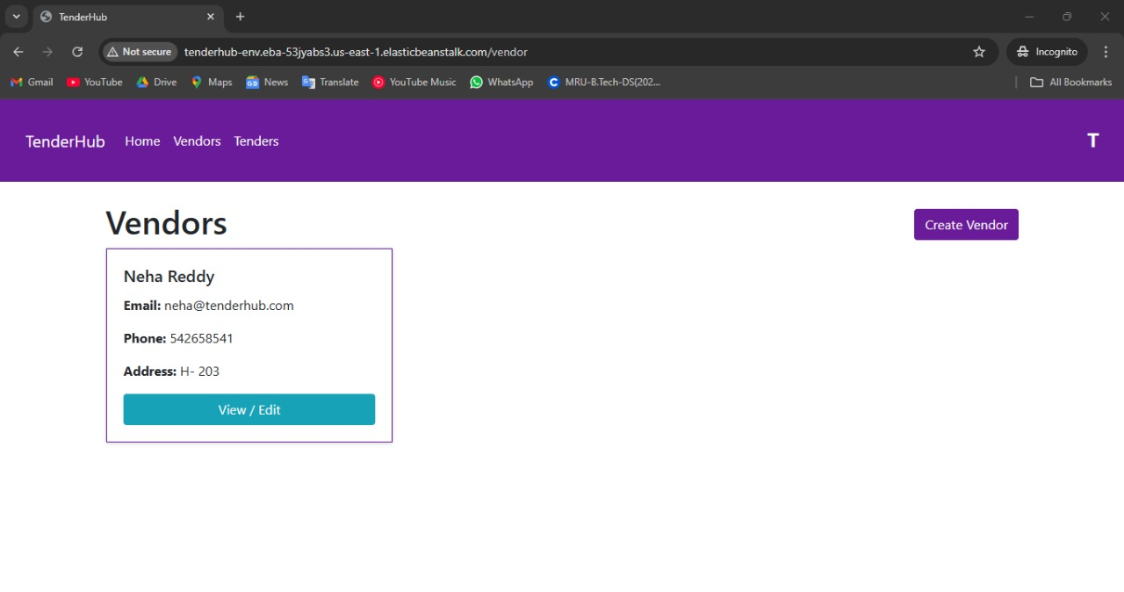

**Fig: 4.4 Vendor Page for Admin**

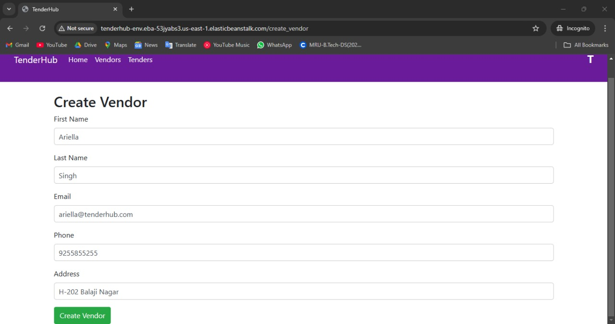

**Fig: 4.5 Create Vendor Page for Admin**

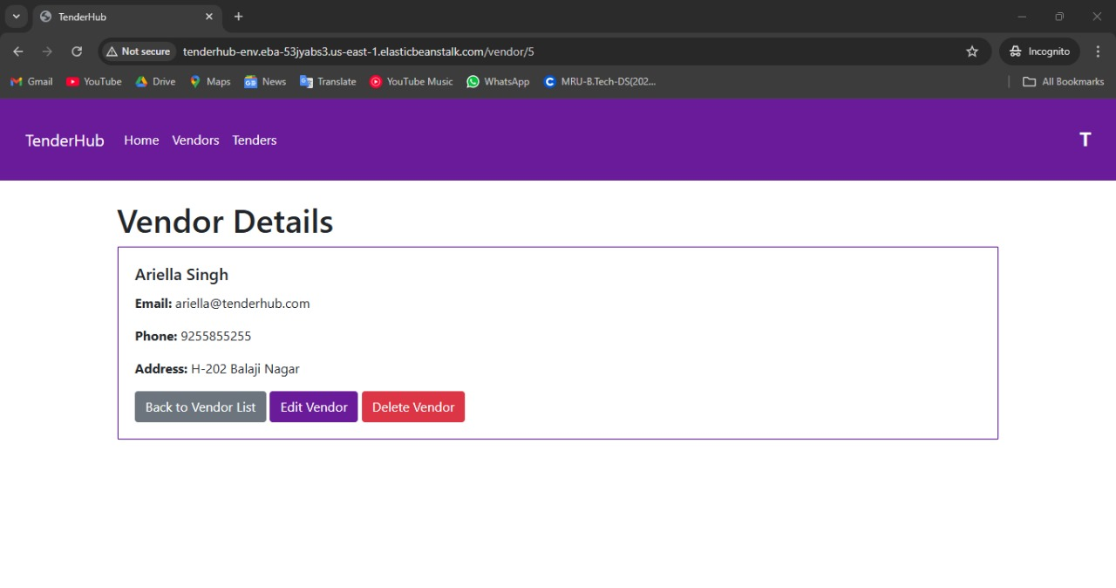

**Fig: 4.6 Vendor details Page for Admin**

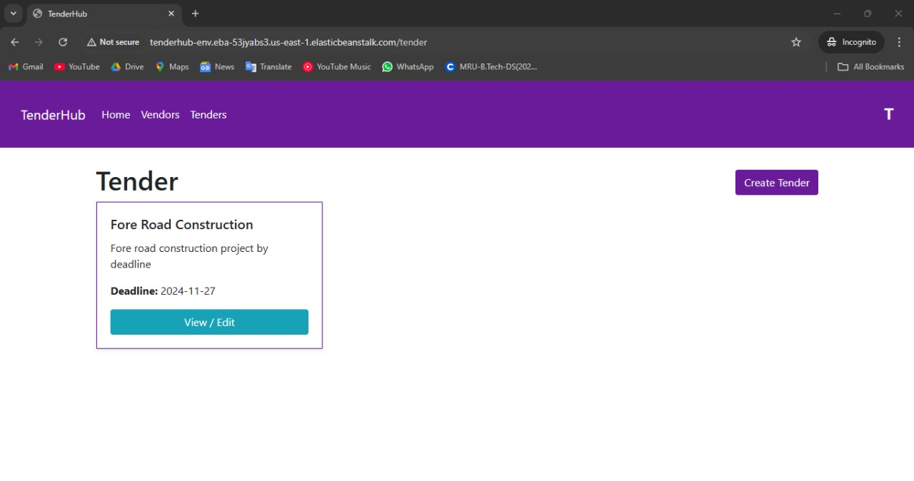

**Fig: 4.7 Tender Page for Admin**

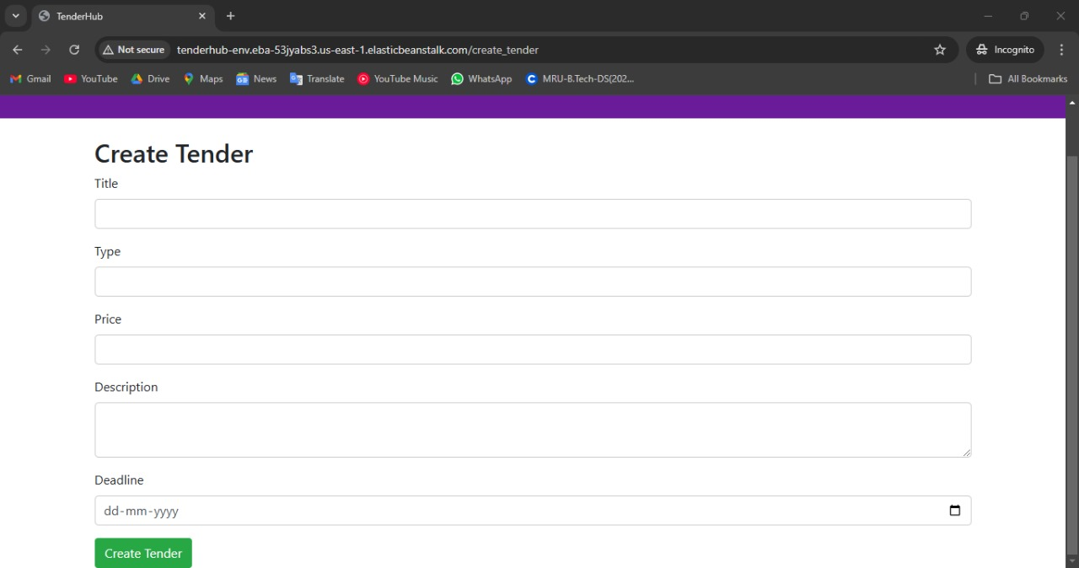

**Fig: 4.8 Create Tender Page for Admin**

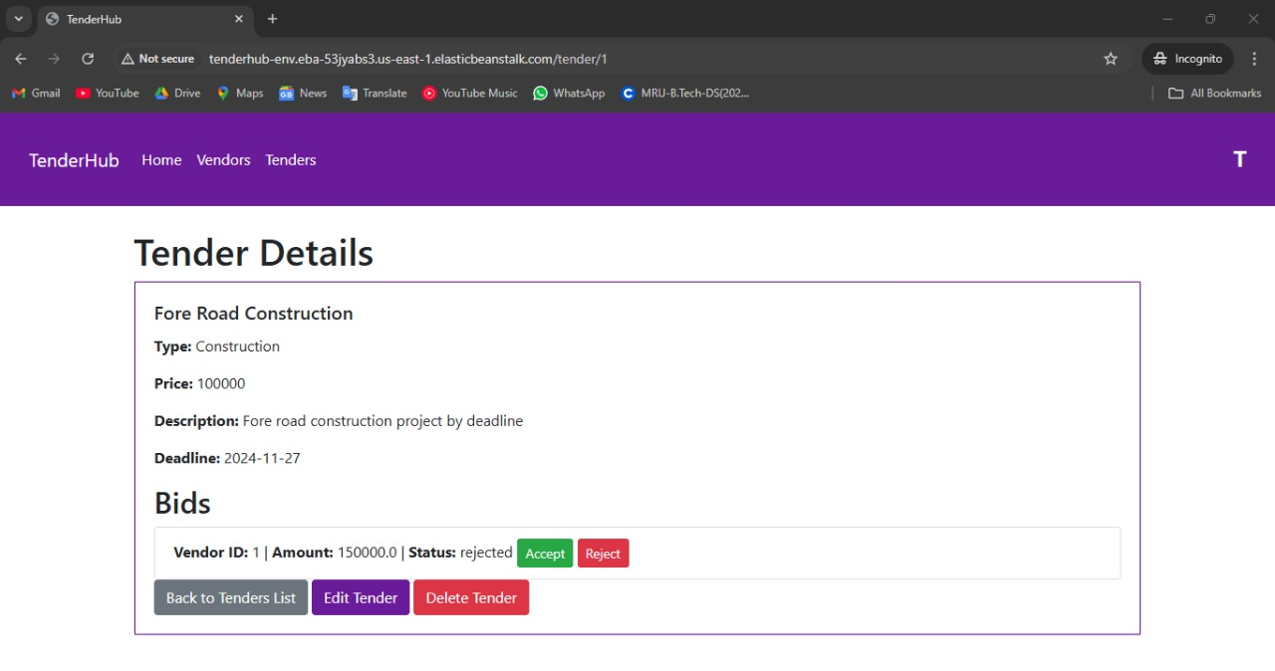

**Fig: 4.9 Tender Details Page for Admin**

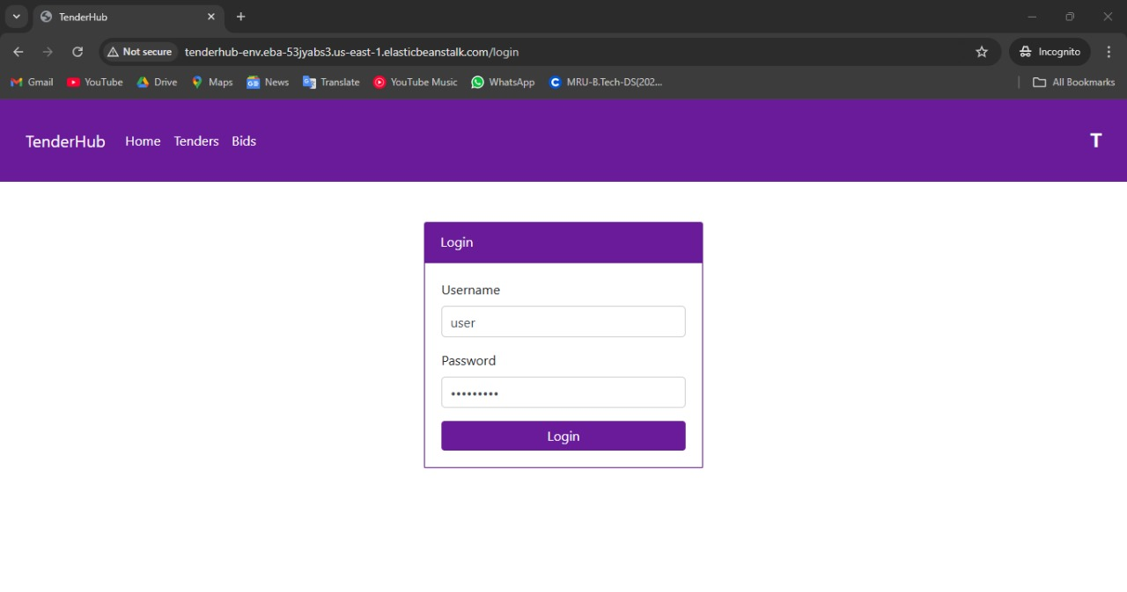

**Fig: 4.10 User Login**

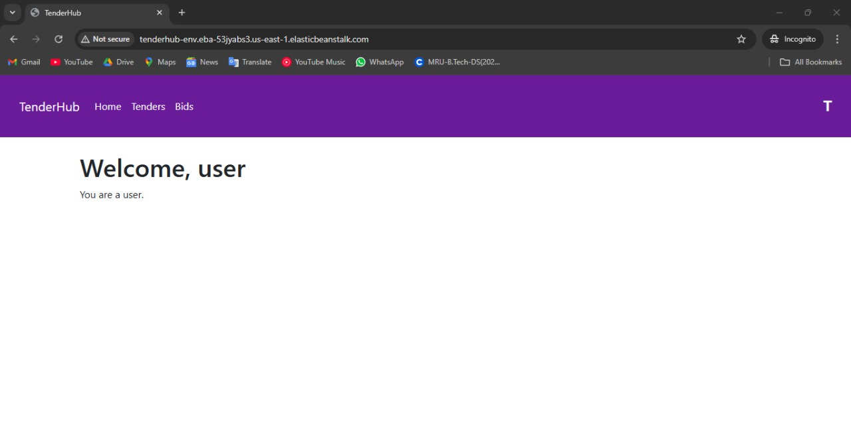

**Fig: 4.11 Home Page for User**

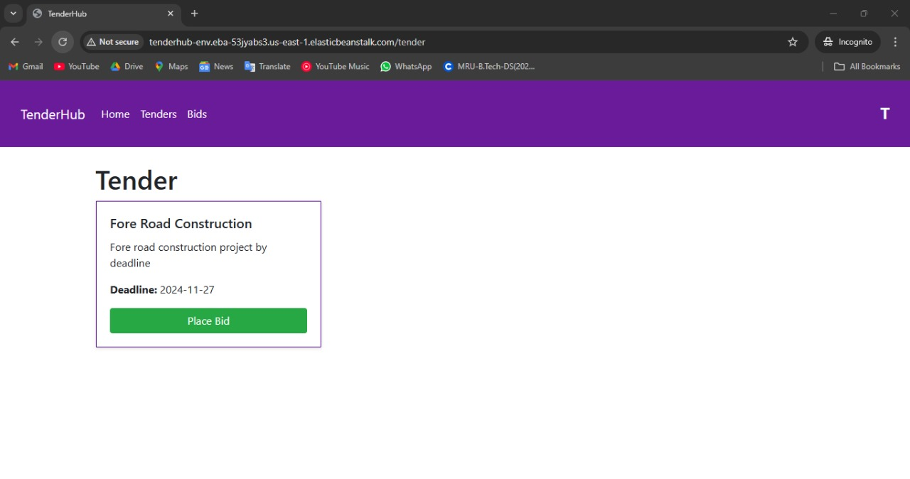

**Fig: 4.12 Tender Page for User**

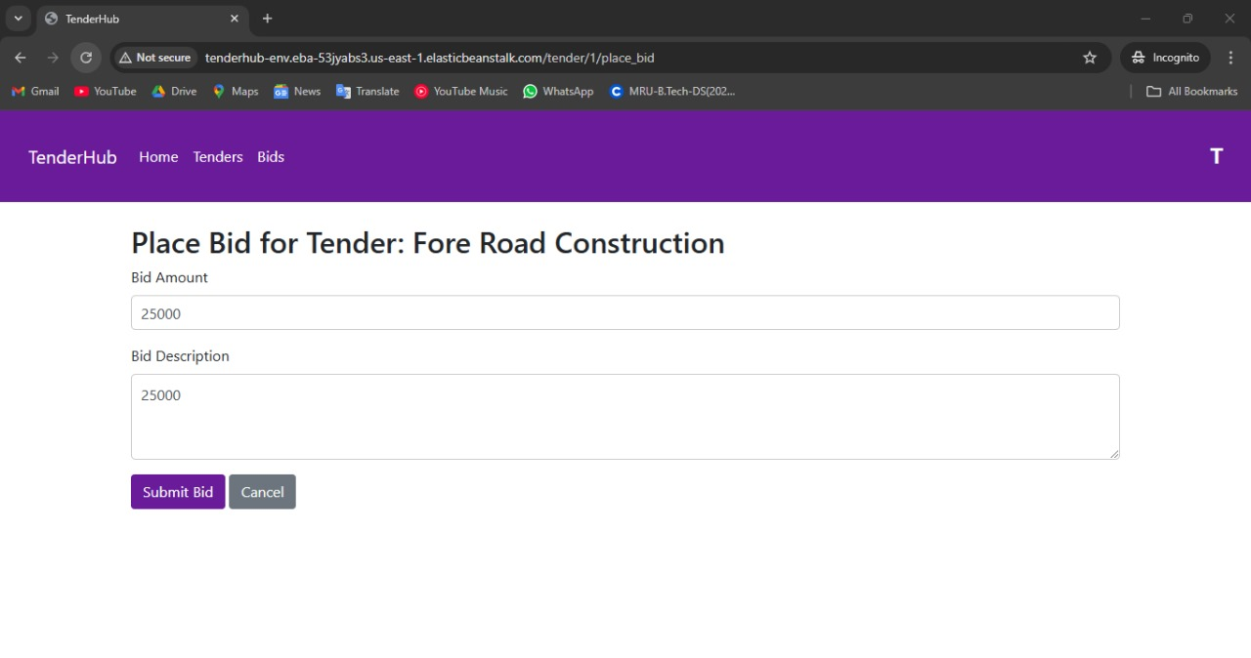

**Fig: 4.13 Place Bid Page for User**

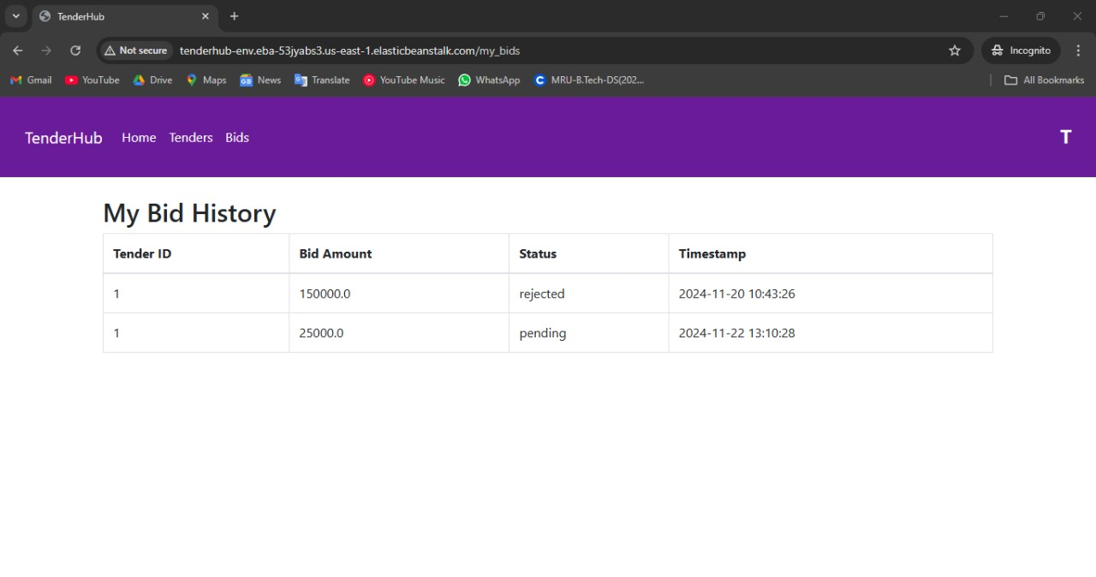

**Fig: 4.14 Bid Page for User**

**Chapter 5 : Conclusions and Future Scope of Study**

**Conclusion**

In conclusion, TenderHub has successfully addressed the complexities of traditional tender management systems by offering a streamlined, user-friendly platform that benefits both administrators and bidders. By using Flask for backend development, HTML/CSS for frontend design, and deploying the application through AWS Elastic Beanstalk, the system is both scalable and reliable. The integration with Amazon RDS ensures secure and efficient management of data, with the ability to handle growing databases as the application scales.

The application was designed with the goal of improving transparency and simplifying tender creation, bid submission, and vendor management. Administrators have the flexibility to create and manage tenders and vendors efficiently, while bidders can access relevant tenders, submit bids, and track bid status in real time. The frontend, built with responsive design principles, ensures that users across various devices experience a seamless interface.

Post-deployment performance monitoring showed positive results, confirming the system's reliability and robustness. While the initial version has proven to meet the core requirements, there is potential for future enhancements, including additional features like automated notifications, real-time bid analysis, and improved reporting tools. TenderHub has laid a strong foundation for digital tender management and has the capacity to evolve into a comprehensive solution for modern organizations.

**Future Scope to Study**

1. **Automated Notifications:**

Implementing email and push notifications for bid status updates, new tenders, and vendor actions to enhance user engagement and real-time communication.

1. **Advanced Analytics and Reporting:**

Adding analytical tools for both administrators and bidders, providing insights into bid trends, vendor performance, and tender success rates, which can aid in decision-making.

1. **AI-Based Bid Selection**:

Leveraging artificial intelligence to automatically suggest the most competitive bids or detect anomalies in bid submissions.

1. **AI-Powered Support Chat:**

Integrating an AI-based chatbot to provide instant assistance, answer user queries, and guide them through the tender submission process, improving user engagement and support.

1. **Notices on Home Page:**

Adding a notice board on the homepage to display important announcements, deadlines, and tender updates, ensuring that users stay informed about critical information.

**References:**

[1] <https://docs.aws.amazon.com/elasticbeanstalk/latest/dg/Welcome.html> - AWS Documentation (2024). Elastic Beanstalk Documentation. Amazon Web Services

[2] <https://www.youtube.com/watch?v=Z1RJmh_OqeA> - Flask Tutorial - YouTube (2024). Flask Web Development Tutorial for Beginners.

[3] <https://github.com/shashirajraja/Tender-Management-System> - Tender-Management-System by Shashirajraja